Lab 07 – Worksheet

Name: Group 07 | ID:10303 | Section: T-2

Selective 2’s complement

Inputs to complement |  |  |  | Outputs of the complement
O | B₂ | B₁ | B₀ | C₂ | C₁ | C₀
0 | 0 | 0 | 0 | 0 | 0 | 0
0 | 0 | 0 | 1 | 0 | 0 | 1
0 | 0 | 1 | 0 | 0 | 1 | 0
0 | 0 | 1 | 1 | 0 | 1 | 1
0 | 1 | 0 | 0 | 1 | 0 | 0
0 | 1 | 0 | 1 | 1 | 0 | 1
0 | 1 | 1 | 0 | 1 | 1 | 0
0 | 1 | 1 | 1 | 1 | 1 | 1
1 | 0 | 0 | 0 | 0 | 0 | 0
1 | 0 | 0 | 1 | 1 | 1 | 1
1 | 0 | 1 | 0 | 1 | 1 | 0
1 | 0 | 1 | 1 | 1 | 0 | 1
1 | 1 | 0 | 0 | 1 | 0 | 0
1 | 1 | 0 | 1 | 0 | 1 | 1
1 | 1 | 1 | 0 | 0 | 1 | 0
1 | 1 | 1 | 1 | 0 | 0 | 1

Write expressions for C₂, C₁ and C₀
Table 7.2
C₂ = | O’B₂+B₂B₁’B₀’+OB₂’B0 + O B2’B1
C₁ = | O’B₁+B₁B₀+OB₁B₀
C₀ = | B₀
Provide appropriately commented code for your selective 2’s complement module
module TwosCompliment(
input O,
input [0:2] B,
output [0:2] C
);
assign C[0] = B[2];
assign C[1] = (~O & B[1]) | (B[1] & ~B[2]) | (O & ~B[1] & B[2]);
assign C[2] = (~O & B[0]) | (B[0] & ~B[1] & ~B[2]) | (O & ~B[0] & B[2]) | (O & ~B[0] & B[1]);

endmodule

Write a testbench to thoroughly test designed complement module.
module comp_test();
reg o;
reg [0:2] b;
wire [0:2] c;
TwosCompliment (o, b, c);

initial begin
o=0; b=3'b000; #10
o=0; b=3'b001; #10
o=0; b=3'b010; #10
o=0; b=3'b011; #10
o=0; b=3'b100; #10
o=0; b=3'b101; #10
o=0; b=3'b110; #10
o=0; b=3'b111; #10

o=1; b=3'b000; #10
o=1; b=3'b001; #10
o=1; b=3'b010; #10
o=1; b=3'b011; #10
o=1; b=3'b100; #10
o=1; b=3'b101; #10
o=1; b=3'b110; #10
o=1; b=3'b111;
end
endmodule

Attach screenshot of Simulation output- make sure to scale properly for visibility of all case.
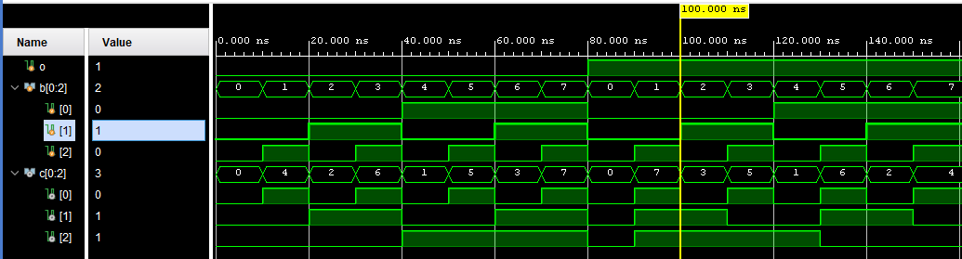
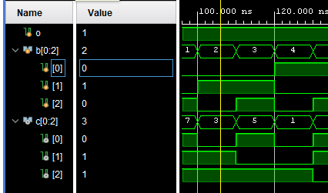
output = 010
2’s complement of 010 is 011

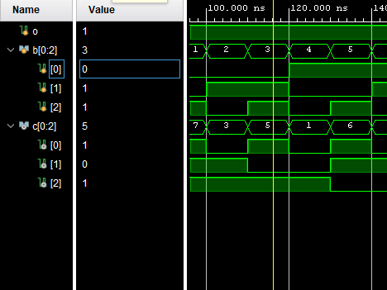
Output = 011
2’s complement of 011 is 101

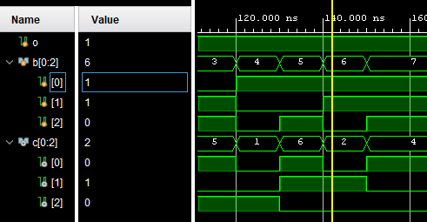
Output = 110
2’s complement of 110 is 010

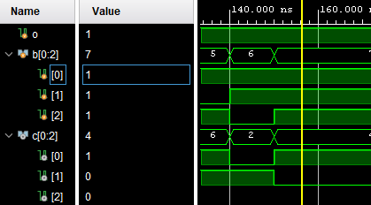
Output = 111
2’s complement of 111 is 100

Adder/Subtractor system

Provide code for design module here
module adder_subtractor(
input O,
input [2:0] A,
input [2:0] B,
output [6:0] S,
output Sign
);

wire [2:0] C;
wire [2:0] Su;
wire Cu;
wire sum;
wire [3:0] D;
wire AND;

complement gate1(O, B, C);
Threebitfulladder gate2(A, C, Su, Cu);

assign sum = (~O|Cu);
assign Sign = (~O|Cu);

complement gate3(sb, Su, D[2:0]);
assign AND_1 = (~O & Cu);
assign D[3] = AND;

segmentDecoder gate4(D, S);

endmodule

Provide RTL Schematic here
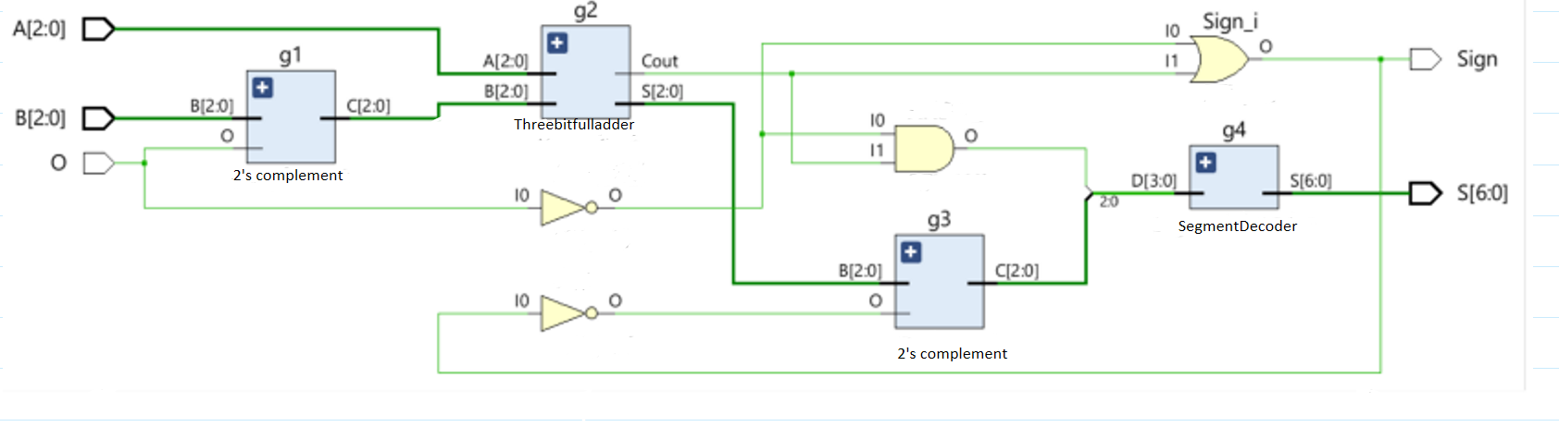

Add your testbench here
module adder_subtractor_testbench();

reg O;
reg [2:0] A;
reg [2:0] B;
wire [6:0] S;
wire Sign;

adder_subtractor t1(O, A, B, S, Sign);

initial
begin
#100 O = 1'b0; B = 3'h3; A = 3'h4;
#100 O = 1'b1; B = 3'h4; A = 3'h3;
#100 O = 1'b0; B = 3'h7; A = 3'h7;
#100 O = 1'b1; B = 3'h0; A = 3'h2;
end
endmodule
Waveform result:
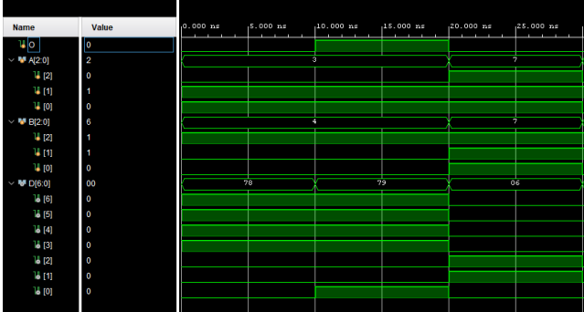
CASE 1: case 1 case 2
3-4 gives output as -1 which is correct
CASE 2:
7+7 segment gives output as “e” which is correct.

Exercise

Use Figure 6.0 and work out for cases when B is zero and subtracted from A. Reflect on the output obtained and suggest ways to fix (if required).

Space to work out on Figure 7.0
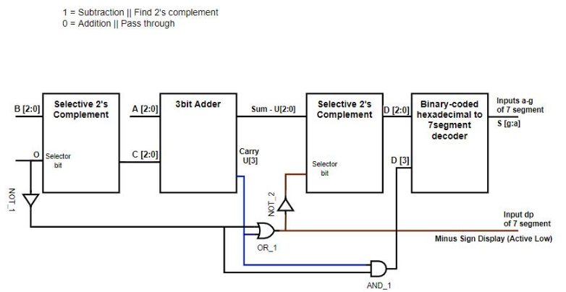

Space for reflection
When analyzing the given circuit for the case where B = 0 and is subtracted from A, the expected output should simply be A itself, since subtracting zero does not alter a value. Since the subtraction operation involves finding the 2’s complement of B, and B is zero in this case, its 2’s complement remains zero. This means that the 3-bit adder is essentially adding A + 0, which should produce A as expected. However, the circuit also contains a second Selective 2’s Complement block before the output is sent to the 7-segment display. If not controlled properly, this additional processing step might introduce an unintended transformation of the sum. A potential issue could arise if the system misinterprets the need for taking the 2’s complement of the sum when it is not required, potentially flipping the sign representation of the result. If the circuit outputs A correctly but displays a negative sign, it suggests that D[3] logic needs refinement. A fix would be to ensure that D[3] is only activated when the result is genuinely negative rather than relying on the default subtraction logic.

Lab Evaluation Rubrics

Marks Distribution:
 |  | LR2  Code | LR4  Data  Collection | LR5  Results | LR7  Viva | LR10  Analysis
In-lab | Task b | 20 points | 5points | 10 points | 10 points | -
In-lab | Task c | 20 points | - | 20 points | 10 points | -
Exercise | Task d | - | - | - | 10 points | 15 Points
Total Marks = | 100 | 40 | 5 | 30 | 10 | 15

Marks Obtained:
 |  | LR2  Code | LR4  Data  Collection | LR5  Results | LR7  Viva | LR10  Analysis
In-lab | Task b |  |  |  |  | -
In-lab | Task c |  | - |  |  | -
Exercise | Task d | - | - | -
Total Marks = | 100

